

Speech given by

Mark Carney, Governor of the Bank of England

At the 146th Annual Trades Union Congress, Liverpool 9 September 2014

President and Congress.

It is a pleasure to be in Liverpool today to discuss the prospects for the UK labour market. The growth and distribution of jobs and incomes matter to everyone.

Employment does much more than provide the means to support workers and their families; it is essential to personal fulfilment and human dignity.

Part of that dignity is being paid a living wage.

Over the past year, the Bank of England has ensured that it pays all of its 3,600 staff at least the living wage. And we have recently brought all our contracted service staff in central London up to the London living wage.

We are in the process of our final review. But I can announce today the Bank’s intention to become an accredited Living Wage employer by the time of the next TUC conference.

Of course, the Bank of England’s responsibilities for promoting the good of the people of the United Kingdom go much further than being a responsible employer.

We manage monetary policy to achieve price stability: low, stable and predictable inflation.

And we promote financial stability by regulating and supervising financial institutions as well as by taking targeted actions to insure against unsustainable indebtedness, as we did earlier this year for the housing market.

By maintaining price and financial stability we put in place the foundations for sustainable job creation and income growth.

Stability gives workers the confidence to invest in skills or to change jobs. And it gives firms the confidence to hire new workers, invest in new equipment, introduce new products and pursue new markets. We need workers with the right skills. And we need companies taking strategic initiatives to grow productivity. That productivity is needed to secure real wage increases over the medium term.

And as I will explain, the labour market is central to our decisions – decisions which must take into account both short-term fluctuations and the profound changes sweeping labour markets across advanced economies.

These changes include:

* Powerful demographic forces, notably the ageing of the workforce, increases in longevity and rising participation of women in the workplace;
* How globalisation and new technologies are splitting production chains across companies and across borders;
* How financial risk is being steadily shifted to employees from both employers and the state through changes to the structure of pensions and benefits, reduced job security and evolving labour market institutions, including the union movement;
* The sharp reduction in the employment share of middle-skilled jobs, relative to more- and less-skilled jobs; so-called job polarisation.1

Collectively, these trends have affected the dynamism of labour markets and the spending patterns of families.

And they have interacted with the forces unleashed by the Great Recession to challenge the durability of the expansion.

The Great Recession led to enormous dislocations in advanced economy labour markets.

In many economies unemployment and underemployment skyrocketed. Youth unemployment reached perilous levels.

Central banks responded with unprecedented monetary stimulus.

That was consistent with their price stability mandates. And it recognised the threat that the recession might permanently scar the workforce.

As the recovery in many advanced economies has evolved, central banks are assessing the extent of structural changes in labour markets and are grappling with what they mean for monetary policy.

The answer is not uniform across major economies. This is one reason why monetary policy in the US, euro area and the UK can be expected to be less synchronised than in recent years.

1 See, for example, Acemoglu, D and Autor, D (2011), “Skills, tasks and technologies: implications for employment and earnings”, Handbook of Labor Economics, Volume 4b, Elsevier.

# A tale of three labour markets

Indeed, despite common underlying influences, differences in how the labour markets of major economies responded to the Great Recession have been striking (Chart 1).

## *The US*

Take the world’s largest economy – the United States – as a benchmark.

Unemployment there more than doubled during the recession. While that rate has recently fallen back, that headline is much better than the details.

The number of Americans in work has only just returned to where it was before Lehman failed, even though there are now 14 million more people of working age.

Much of the fall in the unemployment rate is the result of workers in their prime leaving the labour force.2 3

Far more vacancies remain unfilled than usual, indicating big mismatches in the labour market. And fewer people than normal are switching jobs, suggesting an ongoing reluctance to take risks.

The American labour market still is not working as it once did.

## *The UK*

Even though times for many families have been tough, relative to that benchmark, the UK labour market has performed well.

Despite a recession that was deeper and more prolonged, unemployment did not rise as much and has fallen back sharply since.4

In contrast to the US, this rapid fall has been accompanied by significantly higher participation rates.

2 See Yellen, J (2014), “Labor market dynamics and monetary policy”, Remarks at the Federal Reserve Bank of Kansas City Economic Symposium, Jackson Hole. In addition, Erceg and Levin (2013) show that there was a reduction in US participation rates of around 2½% between 2007-12. Of that, rates fell most markedly among the young (reflecting higher educational enrolment) and ‘prime age’ adults 25-54 years old. There was a sharp up-tick in older workers claiming forms of social insurance; but that was partly offset by higher participation rates among older workers, perhaps reflecting a need to offset lost retirement income. Erceg, C and Levin, A (2013), “Labour force participation and monetary policy in the wake of the Great Recession”, IMF Working Paper No. 13/245, July.

3 The 3pp fall in the participation rate is a marked break from its stable level in the preceding decade. Overall participation was flat at around 66% between 2004-7. It had fallen to below 63% in early 2014 (Bureau of Labour Statistics). By contrast, before that, and over the longer run, participation rates had been essentially acyclical – invariant to business cycle conditions (Erceg and Levin, 2013).

4 Outturns for unemployment have remained some way below what would have been expected given the past relationship between changes in unemployment and growth (Okun’s law). Year-on-year increases in unemployment during 2008-9, for example, remained around 1ppt below a simple Okun relationship based on data since the early 1970s. That is in stark contrast to the experience of the US

in that period, where unemployment outturns were some way above past Okun’s law relationships.

There are now over one million more people in work in the UK than at the start of the crisis. Total hours worked are some 4% above their pre-crisis level.

That exceptional employment performance has come at a cost, however: wage growth has been very weak. Adjusted for inflation, wages have fallen by around a tenth since the onset of the crisis.

To find such a fall in the past, you would have to look back to the early 1920s.

The weakness of pay has, in effect, purchased more job creation. It has not resulted in an unusually high level of profits.

The burden of the Great Recession has been shared across the UK. Profits have been squeezed almost as much as labour costs. Employees have seen their real incomes reduced, but more people are in work as a result.

In the US, the burden has been much more concentrated on those who have lost, and not regained, work. And in contrast to the UK, American companies have increased their profits significantly as a share of national income.

## *The euro area*

What makes the UK performance even more remarkable is that we have faced the added challenge of rebuilding competitiveness.

In the run-up to the crisis, the UK’s economy had become increasingly imbalanced.

When the crisis hit, sterling fell by a quarter. Prices of imported goods rose sharply and that fed through to higher inflation.

The squeeze on real incomes was pronounced. And yet there were relatively few calls for higher wages to compensate.

As a result of that painful adjustment, the UK is more competitive. And if the world economy returns to a surer footing, there is a real prospect that the UK can properly rebalance its economy.5

Euro-area countries have needed to make similar – if larger – adjustments to restore competitiveness but with less flexible labour markets and without a flexible currency (Charts 2-4).

5 See Carney, M (2014), Speech at the Mansion House, June; and Broadbent, B (2014), “The balance of growth”, Speech at the London School of Economics, January.

The results have been dire. Euro-area unemployment has risen sharply over two successive recessions to its current rate of over 11%. It stands at over 14% in Portugal, 20% in Spain, and 25% in Greece.

Over 6% of the euro-area labour force is now long-term unemployed and in danger of becoming detached from the labour market.6 And despite high unemployment, there is evidence of labour shortages.7

There is a clear danger of a misplaced if not lost generation of workers in the euro area and in the US. Britain’s labour force and trade unions deserve great credit for ensuring that this risk is much lower in the UK. By sharing the burden, our economy is better positioned for the future. The question is whether we will seize the opportunity.

# Why the UK labour market outperformed: a labour supply shock

Before considering how we can, it is helpful to understand just why the UK labour market has outperformed.

When the recession hit, the demand for labour naturally fell. But surprisingly the potential supply of labour appears to have increased as well with an estimated 1.5 million people entering the labour force.

The number of additional people wanting to work overwhelmed the longer-term effects of population ageing, which, all else equal, would have been expected to have removed around half a million people from the labour force (Chart 10).

This expansion of the workforce is being driven mainly by women and older workers. Before the Great Recession, between 46% and 83% of those in the 50- to 64-year-old age cohort were active. Now it is between 60% and 89% (Table 1). In part this reflects a continuation of past trends within age cohorts, but it goes much further.8

The greater risks and financial burdens that many are now facing are likely to be important drivers of the recent increase in the labour force.

6 The average of European Commission, OECD and IMF estimates of structural unemployment have increased from 8.8% in 2008 to 10.3% in 2013, reported in Draghi, M (2014), “Unemployment in the euro area”, Speech at the annual central bank symposium in Jackson Hole, August.

7 There is evidence of there having been an increase in skills mismatch both in the rightward shift of the euro-area Beveridge curve and as indicated by skills mismatch indices. See Draghi (ibid.).

8 Since 2007, annual average growth in participation rates has increased by 3 basis points for those between 50 and 59 years old to

between 10 and 15 basis points (Table 1). For those over 65, the increase in participation growth rates has been around 6 basis points. Growth in participation rates also increased by around 5 basis points for those in age cohorts between 35 and 49 since 2007.

Changes to pension arrangements have encouraged people to work longer.9 State pension ages are rising, and the default retirement age has been abolished.10

Reforms to the UK’s welfare system, including attaching job-search conditions to welfare payments, could have prompted those affected to seek work.11

Sharp falls in wealth and increased uncertainty about future incomes following the financial crisis have undoubtedly changed many people’s retirement plans, making them work longer and retire later in order to compensate.12

And the scale of the debt accumulated by Britain’s households in the run-up to the recession has encouraged more people to work, and to work longer. 13 Around 40% of households reported being concerned about their levels of debt in 2013.14 Almost a tenth of households in a recent Bank of England survey said they were working more because of concerns about repaying their debt.

So the strong performance of the UK labour market reflects in part people feeling compelled to work for financial or other reasons.

When British workers have been challenged, they have not given up (Charts 5-8). Some have taken less productive or lower-skilled jobs. Others are working part-time. Some have become self-employed. Others are prepared to do the same work for less than they would have done.

9 Banks et al (2005) find that those in (predominantly final-salary) employer defined benefit plans report chances of working at age 60 that are, on average, 3 percentage points lower than those of individuals in the State Earnings-Related Pension Scheme (SERPS), an average-earnings-based defined benefit scheme. Those with defined contribution pension arrangements report probabilities up to

7 percentage points higher than those in SERPSs. See Banks, J, Emmerson, C and Blundell, R (2005), “The balance between defined benefit, defined contribution, and state provision”, Journal of the European Economic Association, 3(2-3):466-76.

10 Cribb et al (2014) find that women’s employment rates at age 60 increased by around 7 percentage points when the state pension

age was increased to 61. Male partners’ employment rates also increased – by around 4 percentage points – perhaps indicating a desire by couples to coordinate their retirement planning. Cribb, J, Emmerson, C and Tetlow, G (2014), “Incentives, shocks or signals: labour supply effects of increasing the female state pension age in the UK”, IFS Working Paper No. 13/03.

11 For example, out-of-work lone parents with older children must now claim Job Seekers Allowance, a benefit with job search conditions

attached, unlike previous Income Support. Consistent with these changes, Blundell et al (2014) find that participation and employment rates appear to have increased strongly (by 8-9%) among lone mothers who were affected by the 2010 changes. Blundell, R, Crawford, C and Jin, W (2014), “What can wages and employment tell us about the UK’s productivity puzzle?”, The Economic Journal, 124 (May). See also Avram, S, Brewer, M and Salvatori, A (2013), “Lone parent obligations: an impact assessment”, Department of Work and Pensions Research Report No. 845.

12 Blundell et al (2014) examine the effects of the peak-to-trough wealth shocks implied by the financial crisis on older workers’ labour

supply. They focus on individuals aged 55-74, and examine whether changes in wealth help to predict future employment patterns in 2010-11 given employment status in 2006-7. They find evidence that shocks to housing wealth helped to predict employment status. For example, compared to the least affected 20% of men, the worst affected 20% of men were 14% more likely to be in work in 2010-1. The authors caution against taking too strong an interpretation of their results, however. For example, the regional house price indices used to calculate changes in housing wealth may be capturing wider regional variation in labour demand.

13 Eggertson and Krugman (2012) illustrate how increased labour supply is one margin through which households that need to de-lever

can do so. Eggertson, G and Krugman, P, (2012), “Debt, deleveraging and the liquidity trap: a Fisher-Minsky-Koo approach”, Quarterly Journal of Economics.

14 See Bunn, P and Rostom, M (2013), “The financial position of British households: evidence from the 2013 NMG Consulting survey”, Bank of England Quarterly Bulletin, Q4.

Wage pressures are, on past relationships, as low as if the unemployment rate were around 10%, not the 6.4% it is today (Chart 9).15

With more workers at competitive wages, companies have been encouraged to hire. They already had reason to favour labour over new capital investment given the higher cost and lower availability of credit following the financial crisis.16

This substitution of labour for capital across the economy has continued to lower productivity per hour worked.

That weak productivity growth is not the result of laziness on anyone’s part. It is a natural consequence of so many people wanting to work and companies employing them in place of capital.

Since the typical economist asks whether what they have observed can work in theory, the annex shows how a ‘labour supply shock’ results in a lower path for real wages and productivity, higher employment, and greater downward pressure on wage growth at any particular rate of unemployment.

Although the adjustment has been painful, trading off lower productivity and wages for much higher employment, on balance it provides a solid foundation for a durable expansion. That is because keeping people in work through a recession maximises the prospects for individuals and the economy.

By staying in work, individuals retain and learn new skills. And they are better placed to participate in the expansion when it gathers force. This can make a material difference to an individual’s lifetime earnings.17

For the economy, maintaining workforce attachment is the best way to ensure that cyclical downturns in aggregate demand for goods and services do not translate into permanent reductions in our economy’s potential to supply them.

As a result, Britain has an opportunity, not often seen after a deep recession, to reach and sustain a higher level of employment than in the past. And workers can maximise their pay prospects.

But, you rightly ask, when will this start? When will Britain get a pay rise?

15 Based on the relationship between average earnings adjusted for inflation expectations and unemployment between 1993 and 2012. See Broadbent (2014), “Unemployment and the conduct of monetary policy in the UK”, Speech at the Federal Reserve Bank of Kansas City 38th Economic Symposium, Jackson Hole, Wyoming.

16 See eg Broadbent (2012), “Productivity and the allocation of resources”, Speech at Durham Business School, September.

17 Oreopoulos et al (2012) estimate that a rise in unemployment by 5 percentage points implies an average initial loss of earnings for new college graduates of around 9 per cent, an effect which fades only after a decade. The persistent effects from adverse labour

market conditions are much larger for individuals in the first year of their careers than for those with a few years of experience. And losses are magnified for those whose earnings are predicted to be lower, based on their college major. See Oreopoulos, P,

von Wachter, T and Heisz, A (2012), “The short- and long-term career effects of graduating in a recession”, American Economic Journal: Applied Economics, 4(1), pages 1-29.

The expansion of labour supply does not mean permanently weak growth of real incomes.

As employment approaches its new higher level, wage pressures should increase and capital investment should continue to recover. Productivity growth should pick up bringing the higher, sustainable pay rises that British workers deserve.18

Specifically, the Bank’s latest forecast expects real wage growth to resume around the middle of next year and then to accelerate as the unemployment rate continues to fall to around 5½% over the next three years.

By the end of our forecast, we see 4% nominal pay growth on average across the economy. This is consistent with our inflation target and the economy’s potential. I will touch at the end of my remarks on how workers and employers can raise that potential.

But first let me turn to the implications of all these labour market developments for monetary policy.

# Monetary policy implications

One of our roles at the Bank of England is to deliver price stability in a way that supports jobs and growth. Our price stability objective is clear: the inflation target of 2% CPI inflation.

Supporting jobs means helping the economy reach the maximum sustainable level of employment. That level changes as the economy changes.

That is why, a little more than a year ago, even though inflation had been above the target for most of the past five years and economic growth was poised to accelerate, we did not raise interest rates from their historic low level of ½%.

We did not because we recognised that the UK had a huge number of unemployed and under-employed workers and that the economy was running below full capacity. We expected inflation to fall back. We saw that confidence might have been returning, but it remained fragile. We knew the nascent recovery was not yet secure.

So we used the flexibility in our remit, given to us by Parliament, to return inflation to the target over a longer period than usual in order to support sustainable jobs and growth.

18 See Barnett, A, Batten, S, Chiu, A, Franklin, J, and Sebastia-Barriel, M (2014), “The UK productivity puzzle”, Bank of England Quarterly Bulletin, Q2, for an analysis of the UK’s ‘productivity puzzle’. The standard view has been that the UK has suffered from a collapse in the underlying growth rate of productivity. On that basis, we would not expect there to be significant scope in future for either productivity or real wage growth. The interpretation of the recent behaviour of the labour market as a labour supply shock has more positive implications for the future.

To make our intentions clear, the Bank committed not to even think about raising interest rates from historic lows at least until unemployment fell back to 7%.

That guidance gave businesses the confidence to hire and invest. It reassured households that the costs of servicing their debts were not about to rise abruptly at a time when they remained particularly sensitive to interest rates. And it evolved with the economy.

The effectiveness of that policy has been reinforced by the healing of the financial sector. Prompted by the Bank of England, British banks have raised over £140 billion in new capital in the past few years. They are right-sizing their balance sheets and re-focussing their businesses.

The recovery has exceeded all expectations. It has momentum. There has been a sustained and sharp fall in the unemployment rate to 6.4%. Over 800,000 jobs have been created in the past year alone. We expect robust growth of 3½% this year and 3% in 2015.

The challenge now is to secure a durable expansion; to make sure the economy realises its full potential. What does that mean for interest rates?

With many of the conditions for the economy to normalise now met, the point at which interest rates also begin to normalise is getting closer. In recent months the judgement about precisely when to raise Bank Rate has become more balanced.

We have no pre-set course, however; the timing will depend on the data.

Moreover, the precise timing of the first rate rise is less important than our expectation that, when rates do begin to rise, those increases are likely to be gradual and limited. Rates will go up only as far and as fast as is consistent with price stability as part of a durable expansion, with the maximum sustainable level of employment.

For a variety of reasons ranging from the weakness in the euro area, to ongoing repair of household balance sheets, we are not expecting interest rates to head back to the levels seen before the Great Recession.19

The actual path of interest rates will be determined by the evolution of the balance of aggregate demand and aggregate supply.

19 See, for example, the Box on page 42 of the August 2014 *Inflation Report*.

Before the crisis, monetary policy largely tracked developments in aggregate demand because the structural dynamics of labour supply and productivity growth were relatively consistent.20 But in the wake of the crisis, the supply side of the economy has been anything but predictable.

Originally, we thought the major uncertainties were centred on productivity growth.

But as the Bank’s Monetary Policy Committee (MPC) has seen wages, employment and productivity evolve, we are increasingly of the view that there has been a material labour supply shock for the reasons that I have discussed.

So we have been paying increasingly close attention to developments in the labour market. Our forecasts for the next three years, and hence our interest rate decisions, are based on key judgements that:

* the number of people participating in the labour force will continue to rise, reaching 64% of the population later in the year and continuing its upward trend of the past decade;
* the unemployment rate that the economy can sustain without generating accelerating inflation will return to where it was before the Great Recession (around 5%), and, at around 5½% now, is currently only a little above that; and
* there is scope for the average hours people work to increase further, reducing by about half the current gap between actual and reported desired hours.

In short, and unlike the US and euro area, the economy is likely to be able to sustain a higher level of employment than in the past. The uncertainty is less the direction of that development and more its magnitude.

To assess that magnitude and its implications for inflation, we are tracking a range of indicators, including those of the prospective paths for wages and unit labour costs.

Actual wage growth, at just 0.6% since a year ago excluding bonuses, is currently very weak.21 However, there are some leading indicators that point to a modest pick up over coming quarters.

For example, job-to-job flows have been increasing (Chart 11) and some surveys of pay growth have picked up more sharply in the last year. Although the relationship between these surveys and average wage growth has become less robust in recent years (Chart 12), they do offer encouraging evidence of better wage prospects for those changing or finding new jobs.

20 See Broadbent (2014).

21 According to the ONS AWE measure, pay excluding bonuses for employees in the economy as a whole was 0.6% higher than a year earlier. Including bonuses, pay growth was -0.2%. In the private sector, the equivalent figures were 0.9% (excluding bonuses) and

-0.1% (including bonuses).

Of course, the pay of existing employees needs to pick up as well. After all, what matters for economy-wide inflation is the average wage relative to economy-wide productivity.22 To that end, we will be closely monitoring pay settlements that are bunched around the turn of the year and taking a steer from the pay of new hires as a potential leading indicator of broader pay pressures.

Some observers have discounted the implications for inflation of the recent weakness of pay growth because it stems from the types of jobs being filled – a ‘compositional effect’. However, these are real jobs being performed by real people, and an increase in lower-skilled lower-wage jobs is one consequence of

working-off the labour supply shock. We also need to be mindful of the possibility that it represents part of a longer-term trend towards job polarisation.

What matters for inflationary pressures, irrespective of the type of job, is the relationship between wages and productivity, as captured by unit labour costs. Across the economy, wage growth is barely above productivity growth. Unit labour costs are currently soft (growing at only around 1% in the economy as a whole), are below the growth rate necessary to meet the inflation target, and indicate that there is further to go before we reach the new sustainable level of employment.

In other words, there is still slack in the labour market that must be used up, and the recent revisions to the profile of UK output up to 2012 seem unlikely to change that assessment materially. That slack is wasteful. And if it were to remain, inflation would remain below the 2% target.

The MPC’s current best collective judgement is that, while it has narrowed rapidly, this slack is broadly in the region of 1% of GDP. As this margin of slack continues to narrow, we expect wages to pick up slightly faster than productivity, and unit labour cost growth should increase, consistent with meeting the inflation target.

However, the MPC expects it will take the better part of three years for this to happen.

With inflation at 1.6%, continuing downward pressure from the appreciation of sterling, and with slack remaining, the current inflation environment is benign. But it will not remain benign if we do not increase interest rates prudently as the expansion progresses. Our latest forecasts show that, if interest rates were to follow the path expected by markets – that is, beginning to increase by the spring and thereafter rising very gradually – inflation would settle at around 2% by the end of the forecast and a further 1.2 million jobs would have been created.

In other words, we would achieve our mandate. There is, as always, uncertainty about the future.

22 It is the average of real unit labour costs across firms in the economy that matters for inflation.

But uncertainty does not mean stasis. You can expect interest rates to begin to increase.

The exact path will depend on the economy. Our assessment will undoubtedly change as the economy evolves and policy will of course be adjusted if geopolitical events have a material impact on the outlook.

If indicators suggest the economy is moving more slowly towards our goals, we will have learned that we are further from sustainable capacity. Prospective wage and unit labour cost growth will be weaker. Rates will go up later and more gradually.

And should we see faster progress, prospective wage and unit labour cost growth will be stronger, which will suggest we are closer to maximum capacity and that the economy can sustain higher rates sooner.

In all events, rate rises can be expected to be gradual and limited compared to the experience of the UK in the past.

# Conclusion

We are under no illusions. The Great Recession was a calamity. Britain’s workers have borne many of the consequences.

Our job is to ensure the economy achieves its potential and to maintain price and financial stability, for sustainable growth in jobs and incomes.

But monetary policy cannot do it alone.

Others – including trade unions, government and businesses – will determine the potential of this economy. You will ultimately determine the size of Britain’s pay rise.

Those in work need to be able to seize new job opportunities in a world where technology and globalisation cause labour markets to shift rapidly.

Skill levels need to be raised continually. That is of course first and foremost about education. But crucially it also means access to lifelong learning, both on and off the job, available to all.

The TUC’s engagement with the UK’s skills agenda is a major contribution to realising that imperative. In the past year alone, unionlearn, has supported over 200,000 people to invest in their skills.

Such investments are crucial for the durability of this economic expansion and for Britain’s future. They will help to deliver long-term productivity – so that the British people get the pay rise they deserve.

# Chart 1: UK unemployment rose by less than in the US initially and fell more rapidly than in the euro area subsequently.(a)

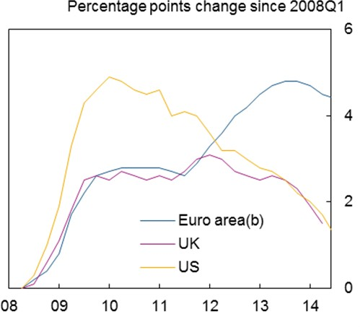

Sources: Eurostat and Bank calculations

1. Percentage of the 15-74 population in the US and euro area. Percentage of the 16-74 labour force in the UK.
2. Data are based on a changing composition of the euro area, which currently includes 18 countries.

# Chart 3: Nominal compensation growth in the UK outstrips that in Spain and Ireland…(a)

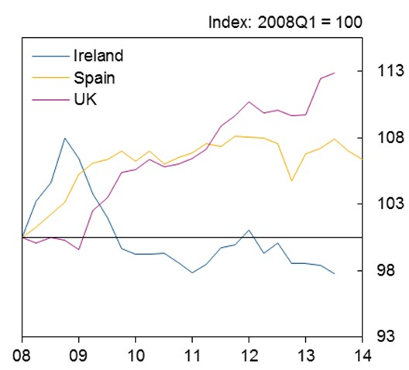

Sources: Eurostat and Bank calculations.

(a) Compensation of employees (expressed in national currencies) divided by number of employees.

# Chart 2: Increase in UK unemployment was considerably smaller than those in Ireland and Spain.(a)

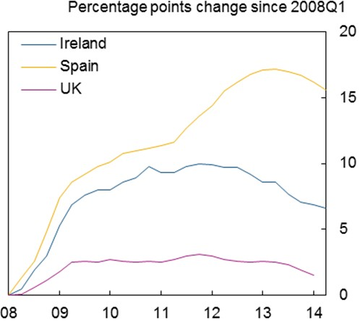

Sources: Eurostat and Bank calculations.

(a) Percentage of the 15-74 population in Ireland. Percentage of the 16-74 labour force in Spain and the UK.

# Chart 4: … but real compensation fell more markedly in the UK, supporting employment.(a)

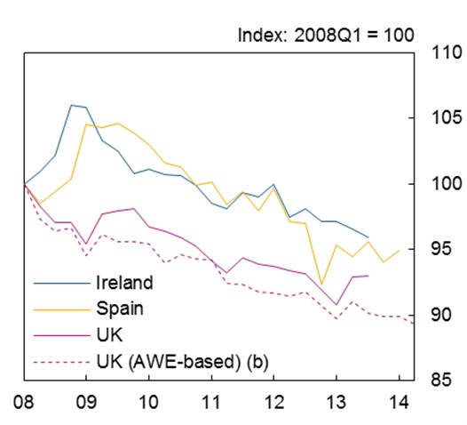

Sources: Eurostat and Bank calculations.

1. Wages and salaries (expressed in national currencies) deflated by CPI and divided by number of employees.
2. Whole economy average weekly earnings (total pay) deflated by CPI.

# Chart 5: More of the rise in employment since the crisis has been part-time than full-time employment, although full-time employment has recovered strongly in the past year.

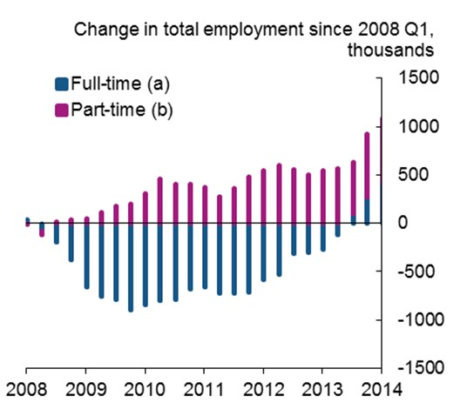

Sources: Labour Force Survey and Bank calculations.

1. Total number of people working full time, based on LFS respondents' self-classification.
2. Total number of people working part-time, based on LFS respondents' self-classification.

# Chart 6: Employment in services has recovered faster than in other sectors.(a)

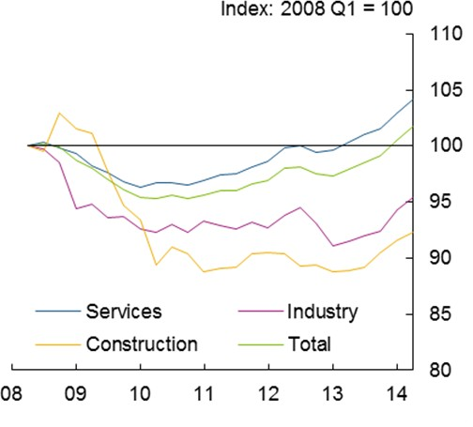

Sources: Workforce jobs and Bank calculations.

(a) Uses Workforce Jobs by industry data seasonally adjusted by ONS. Industries are grouped by Standard Industrial Classification (SIC) 2007.

# Chart 7: Employment growth has been strong among the most highly skilled since the crisis, but low-skilled employment has recently rebounded.

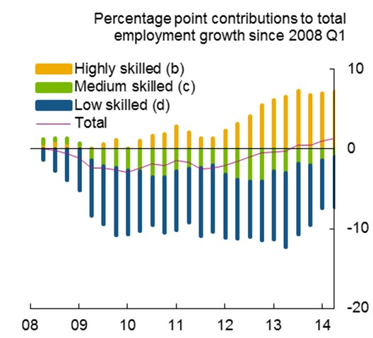

Sources: Labour Force Survey and Bank calculations.

1. Uses the Standard Occupational Classification (SOC) 2000. Seasonally adjusted by Bank staff.
2. Includes managers, professional and associal professional and technical occupations.
3. Change in total employment less changes in high and low-skilled occupations.
4. Includes elementary occupations, plant machine operatives, sales and customer services.

# Chart 8: The UK Beveridge curve has been returning towards its past position.

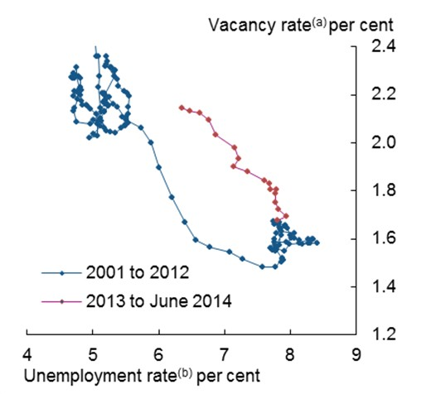

Sources: Labour Force Survey and ONS Vacancy Survey

1. Total vacancies divided by number of people aged 16+ in employment.
2. Number of unemployed aged 16+ as a share of the active population aged 16+.

# Chart 9: UK wage growth is substantially weaker than would have been predicted by its past relationship with unemployment.

**Chart 10: Aggregate participation rate would have been around 1ppt lower had participation rates across age cohorts remained constant at 2007 levels from the start of the crisis.**

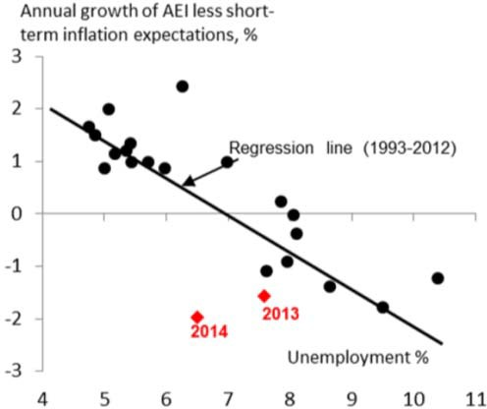 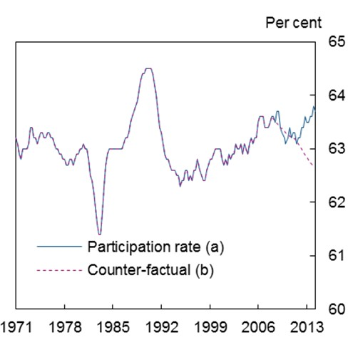

Source: Broadbent (2014). Source: Labour Force Survey and Bank calculations.

* 1. Economically active as a share of the 16+ population.
  2. Counter-factual estimate fixing age- and gender- specific participation rates at their 2007 levels, and using actual population shares.

# Chart 11: Private sector job-to-job flows have picked up, having moved closely with wages in the past, but less closely recently…

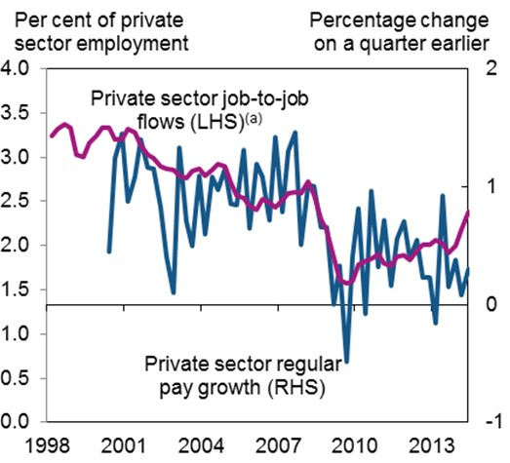

Source: ONS, Labour Force Survey and Bank calculations.

(a) The number of people who report being in a private sector job in the first quarter, and then report being in a private sector job for less than three months in the second quarter of the survey.

# Chart 12: The REC survey measure of pay for new recruits has picked up sharply, but its relationship with official data on average pay has become less robust.

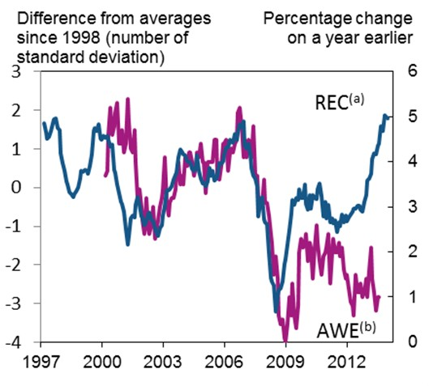

Source: ONS, KPMG/REC/Markit and Bank calculations.

1. Left-hand scale, lagged three months. The REC measure is produced by weighting together survey indices for the pay of permanent and temporary placements using shares in employment.
2. Right-hand scale. Private sector regular pay growth versus single month a year earlier.

# Table 1: Participation rates by age cohort (per cent)

|  |  |  |  |  |  |
| --- | --- | --- | --- | --- | --- |
|  | *Participation Rate in 1994* | *Participation Rate in 2007* | *Latest Participation Rate*  *(2014Q1)* | *Annual average increase (1994‐*  *2007)* | *Annual average increase since*  *2007* |
| 16‐24 yrs | 72.30 | 66.77 | 65.75 | ‐0.10 | ‐0.14 |
| 25‐29 yrs | 83.45 | 84.41 | 93.05 | 0.02 | 0.03 |
| 30‐34 yrs | 82.58 | 84.37 | 93.64 | 0.04 | 0.06 |
| 35‐39 yrs | 84.08 | 84.38 | 93.60 | 0.01 | 0.06 |
| 40‐44 yrs | 86.02 | 86.15 | 92.80 | ‐0.01 | 0.04 |
| 45‐49 yrs | 85.43 | 85.56 | 91.60 | 0.01 | 0.05 |
| 50‐54 yrs | 79.07 | 82.47 | 88.75 | 0.07 | 0.10 |
| 55‐59 yrs | 65.99 | 71.78 | 81.82 | 0.12 | 0.15 |
| 60‐64 yrs | 37.93 | 46.25 | 59.95 | 0.15 | 0.15 |
| 65‐69yrs | 10.87 | 16.23 | 25.76 | 0.11 | 0.17 |
| 70‐74 yrs | 4.49 | 6.79 | 12.43 | 0.05 | 0.11 |
| 75+ yrs | 1.85 | 1.80 | 4.90 | 0.00 | 0.05 |

Source: Labour Force Survey and Bank calculations.

# Appendix: stylised description of labour market dynamics

This appendix sets out a stylized description of recent labour market dynamics derived from a simple model.

First, suppose firms employ labour *N* to produce output *Y = N1-a*, where *1 - a* is the labour share of income. Firms pay a real wage of *W*. As a result, they demand labour up to the point at which the real wage equals its marginal product, or, in log-linear terms:

*w = y - n* (LD)

Equation (LD) is the *labour demand* curve. For given final demand, *y*, labour demand is a decreasing function of the real wage, *w*.

Second, households supply labour, trading off the disutility of working more with the extra consumption higher wage income brings. The simplest resulting labour supply curve is:

*w = 仰n* (LS)

This condition says that households supply more labour when the real wage is high, governed by the (inverse) Frisch elasticity *仰*.

The two curves LS and LD deliver labour market equilibrium real wage and employment. That is illustrated in Figure 1.

# Figure 1: Labour market equilibrium. Figure 2: Demand and labour supply shocks

**reduce wages but can result in higher employment.**

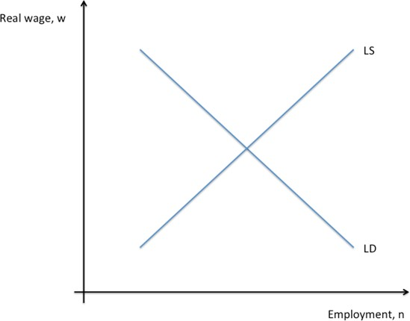 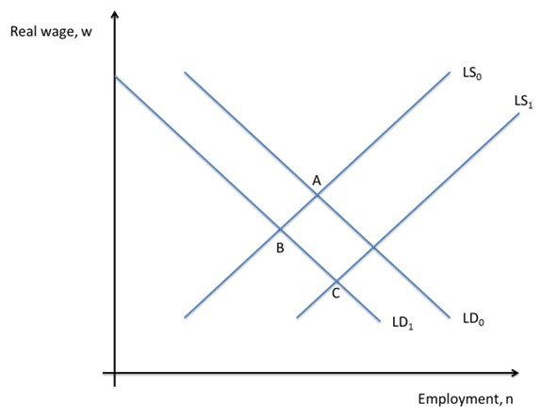

This simple framework can be used to depict – in a simplified way – the dynamics of the crisis, as in Figure 2.

First, a large shock to demand shifted the labour demand curve leftwards (from LD0 to LD1). The economy moved from point A to point B. Employment fell, unemployment rose, and wages fell. This captures, in simple terms, some features of the initial phase of the crisis.

Second, in the more recent past, labour supply rose (from LS0 to LS1), reflecting a number of forces discussed in the text. The economy moves from point B to point C, so employment recovers (to above its pre-crisis equilibrium), but wages continue to fall.

# Weak wage growth

With some additional structure, the simple model above can be used to understand unemployment and wage inflation.23 If wages are adjusted infrequently (ie there is nominal wage stickiness), then the following relation between wage inflation, *冗w*, and unemployment can be derived:

*冗w - f]E冗w = - 仰(u - u-)* (WPC)

*+1*

where *f]E冗w* captures expected inflation, *u-* is the ‘natural’ rate of unemployment (which can vary over time) and is a parameter capturing the degree of wage stickiness. Equation (WPC) is the *Wage Phillips Curve*. For a given natural rate of unemployment, WPC traces out the relationship between wage growth and unemployment. Chart 9 contains a reduced-form representation of the WPC, taken from Broadbent (2014).

*+1*

As that chart shows, outturns for wages in 2013 and 2014 were considerably below the past relationship, which would otherwise suggest that unemployment would be expected to be around 10% given the observed decline in wages. In light of equation (WPC), one way to interpret this is as there having been a decline in *u-*, the natural rate, such that a given rate of unemployment puts greater downward pressure on wages.

Broadbent (2014) discusses Chart 9 further.

23 See Gali, J (2011), “The return on the wage Phillips curve”, Journal of the European Economic Association, 9(3), June.